**PROJECT REPORT**

**ON**

**SMART LIGHT USING IC-555**

**SUBMITTED BY TEAM MEMBERS**

**K.ISHWARAYA (21VV1A0434)** **S.HARIKA (21VV1A0456)**

**T.MOHAN SRI BALAJI (21VV1A0461)**

**V.ASHOK KUMAR (21VV1A0464)**

**Under Fulfillment of project in 2nd B.Tech 1nd semester**



**Department of Electronics and Communication Engineering.**

**University College of Engineering, Vizianagaram.**

**Vizianagaram-535003,A.P,India.**

# ABSTRACT

Electricity is one of the most important resources in this century. We should conserve the electricity. Many times we forget to switch off our lights in day time and electricity is wasted. To overcome this we are going to implement a project named “Automatic Evening Lamp”. Main concept behind this project is to sense light intensity. When sun light is enough for lightening then lamp get switched off automatically. this will help to save electricity.

As soon as the sunlight goes under the visible region of our eyes this system automatically switches ON lights. Light Dependent Resistor (LDR) is a type of sensor which actually switches ON Lights. Light Dependent Resistor (LDR) is a type of sensor which actually does this work and senses the light as our eyes does. As soon as the sunlight comes, visible to our eyes it automatically switches OFF lights. There is no need of manual switching.

**AUTOMATIC EVENING LAMP USING IC-555**

# INTRODUCTION:

The Automatic Street Light using 555-Timer Circuit IC works as a automatic switch. Normally the turning on/off of the light is done manually using a switch whenever there is need of a light. But here we have designed a system where there is automatic turning on and off of the light whenever required.

When darkness is detected then the sensor circuit gets activated and switches ON automatically and when there is another source og light during day time, the street light gets OFF. Also, this circuit can be used to adjust the sensitiveness of the light. The circuit is simple and based on 555-Timer IC and LDR.

**THE PROJECT TITLE IS:**

AUTOMAYIC EVENING LAMP USING IC-555:In this project, we will show you how to design Automatic Evening Lamp Using Timer IC-555. This circuit simulates the street light ON/OFF Automatically. This circuit switches on the light when it is dark condition and switches off when it is not in dark condition. In this circuit the LDR(Light dependent resistor or Photoresistor) is used as the sensor.

**COMPONENTS REQUIRED:**

* L.D.R(Light Dependent Resistor)
* IC NE555 With Base
* Resistors: 2 x 10K, 330**Ω**
* 100K Potentiometer
* **Light Emitting Diode(LED)**
* **Breadboard**
* **Few Breadboard Connectors**
* **(5-12)V Power Supply**

**DESCRIPTION OF EACH COMPONENT:**

**BREAD BOARD**: Bread Board is a construction base for prototyping of electronics Because the solder less bread board does not require soldering, it is reusable, this makes it easy to use for creating temporary prototypes and experimenting with circuit design.

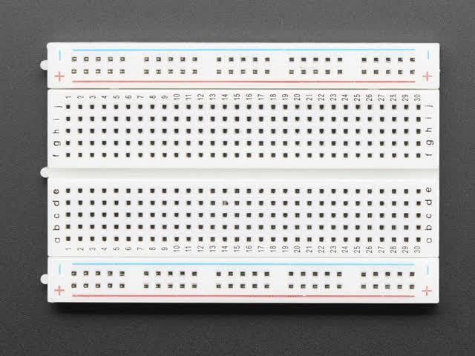

**RESISTORS** : A resistor is a passive two terminal electrical component that implement’s electrical resistance as a circuit element. In electronics circuits resistors are used to reduce current flow ,adjust signal level, to divide voltages, bias active elements and terminate transmission lines.

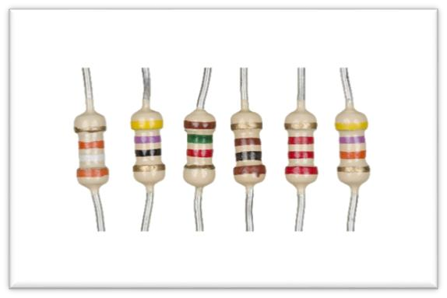

**CONNECTING WIRES** : Connecting wires allows an electrical current to travel from one point on a circuit to another, because electricity needs a medium through which to move in case of computers, wires are embedded into circuit boards, carrying pulses of electricity that are interpreted as binary signals of zeroes and ones.

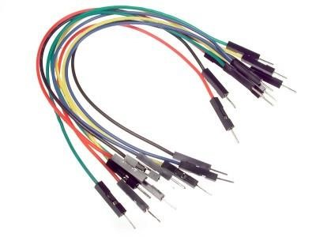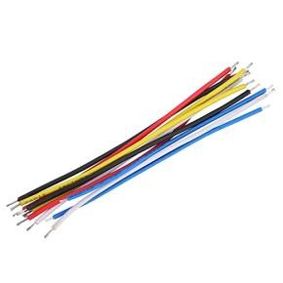

**555 TIMER :** Here, 555 timer runs in free running mode i.e. Astable Mode. It produces pulses whose width can be varied. 2nd and 6th pins are shorted to allow triggering after every cycle. 4th pin is connected to Vcc to avoid sudden response

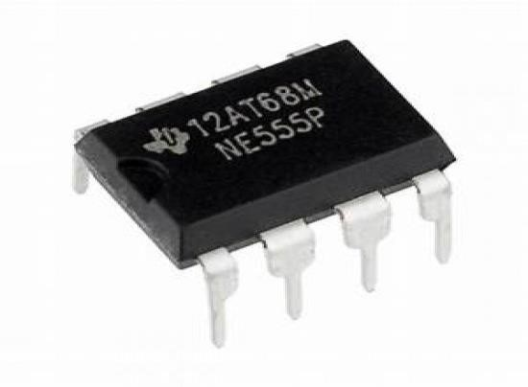

**9 VOLT BATTERY** : The nine volt battery in its most common form was introduced for the early transistor radios. It has rectangular prism shape with rounded edges and a polarized snap connector at the top. This type is commonly used in walky talkies, clocks..

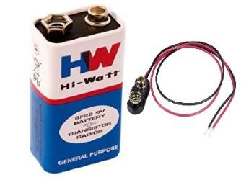

**CAPACITOR** :Capacitor is an electronic component that stores and releases electricity in a circuit. It also passes alternating current without passing direct current. A capacitor is an indispensible part of electronic equipment and is thus almost invariably used in an electronic circuit.

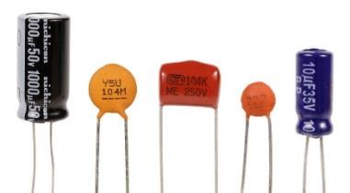

**LED:**  A light-emitting diode (LED) is a semiconductor light source that emits light when current flows through it.The basic principle is that electrons and holes in semiconductors recombine and emit photons under forward bias.

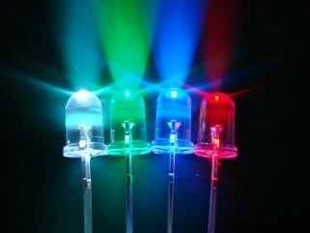

**LDR(Light dependent resistor):**

A LDR is a passive component that decreases resistance with respect to receiving luminosity(light) on the component’s sensitive surface. The resistance of the photoresistor decreases with increase in incident light-sensitive. A photoresistor can be applied in light-sensitive detector circuits and light-activated and dark-activated switching circuits acting as a resistance [semiconductor](https://en.wikipedia.org/wiki/Semiconductor). In the dark, a photoresistor can have a resistance as high as several [megaohms](https://en.wikipedia.org/wiki/Ohm) (MΩ), while in the light, a photoresistor can have a resistance as low as a few hundred ohms.

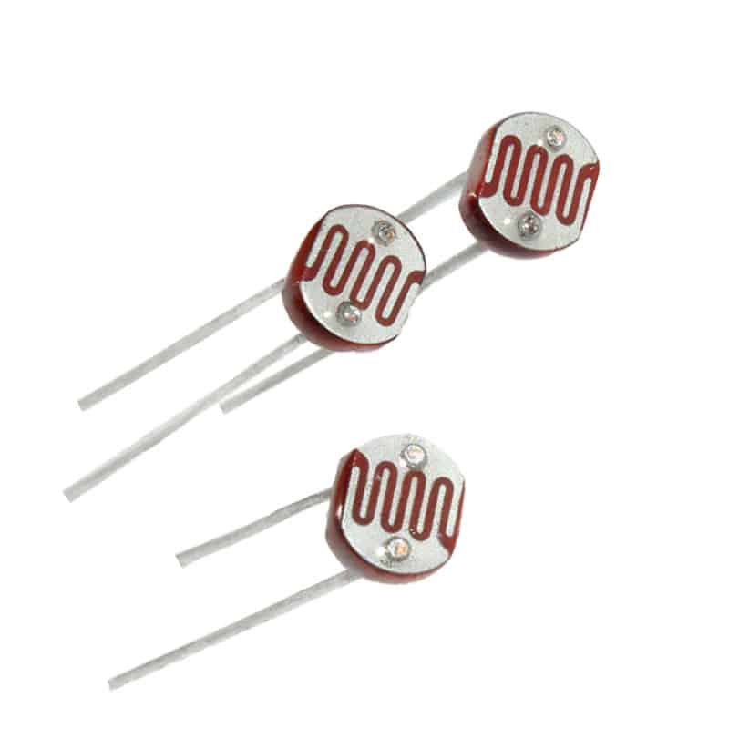

**WORKING PRINCIPLE :**

 The resistance of LDR (Light Dependant Resistor) is inversely proportional to the intensity of light falling on it. It implies that if the intensity of incident light is high, the resistance of LDR will be less and vice versa.

On the other hand, a 555 timer IC gets activated when its reset pin (Pin-4) receives a voltage greater than 0.8V. Once the IC is activated, the voltage at Pins-2,6 need to be between 1/3rd and 2/3rd of the supply voltage, for the output to be ON. For example if the voltage at the reset pin is above 0.8V and the voltage at Pins-2,6 is half the supply voltage, the output turns ON.

In the circuit, we created a voltage divider using LDR and a resistor + potentiometer. It is then connected to Pin-4 (reset) of 555 timer IC. So when it’s dark, the LDR’s resistance increases and so the voltage at the voltage divider drops below 0.8V, causing the 555 timer IC to turn OFF. When there is enough light, the voltage at the reset pin goes above 0.8V and the IC turns ON.

The two 10K resistors are used to divide the supply voltage by half and provide it at the Pins-2,6. This makes sure that the IC’s output turns ON whenever it is activated.

**APPLICATIONS :**

* Used in automatic street light circuits.
* Used to automatically turn on wardrobe or locker lights whenever they are opened.
* Used to automatically turn on wardrobe or locker lights whenever they are opened.

**LIMITATIONS :**

* The values of the resistors should be same to get the perfect output.
* The connections should be make as per the circuit diagram to get the perfect output.

CIRCUIT DIAGRAM:

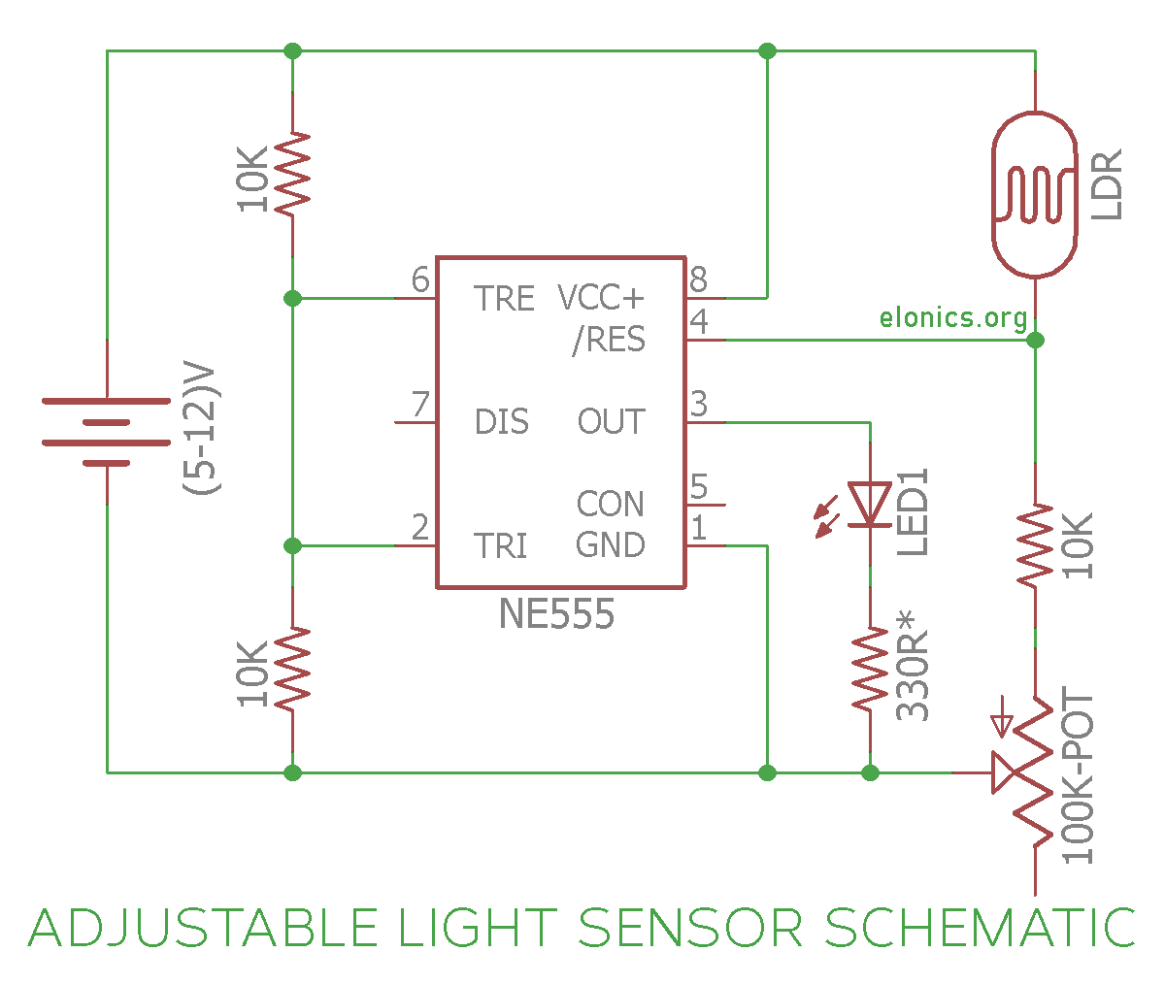

**SOFTWARE SIMULATION USING :**

**CASE 1:** when the surrounding light is enough.

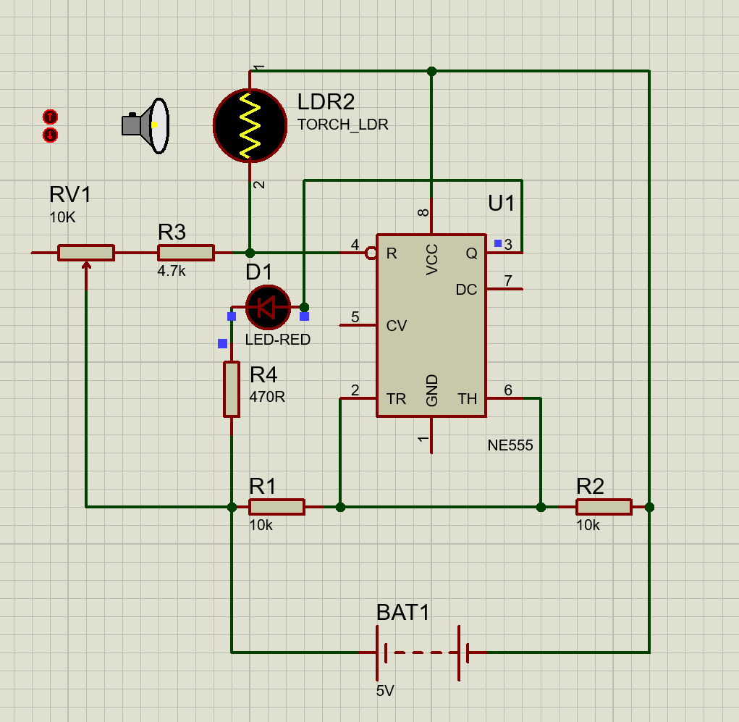

**CASE 2 :** When the surrounding is dark.

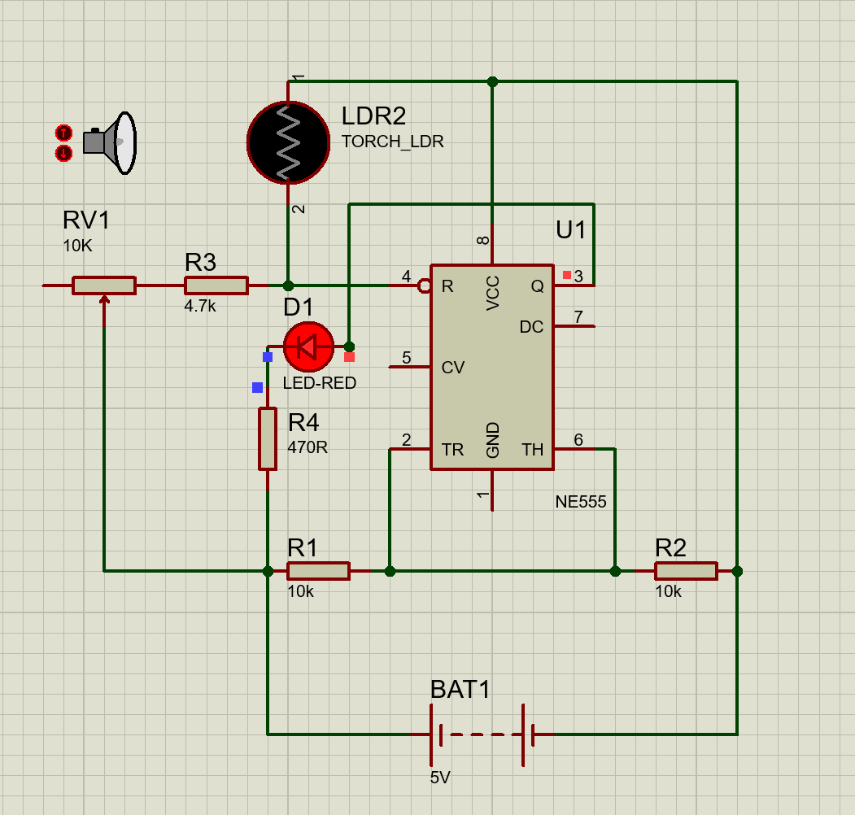

**HARDWARE PROCEDUREON BREADBOARD:**

* Place 555 Timer IC on the Breadboard. I have placed the IC such that its notch faces left. So the pin-numbering starts from bottom left (Reference: Pin-Outs of 555 Timer).
* Connect Pin-8 of the IC to Positive Rail & Pin-1 of the IC to Negative-Rail. (We used the holes in top-second row as Positive-Rail and the holes in bottom-second row as Negative-Rail).
* Connect Pin-2 & Pin-6 of the IC.
* Place a 10K Resistor on breadoard such that one of its terminals is connected to Pin-2 of 555 timer IC. Connect other terminal of the resistor to Negative-Rail.
* Place a 10K Resistor on breadboard such that one of its terminals is connected to Pin-6 of 555 timer IC. Connect other terminal of the resistor to Positive-Rail.
* Now Place an LDR (Light Dependent Resistor) on breadboard such that one of its terminals is connected to Pin-4 of 555 Timer IC. Connect its other terminal to Positive-Rail.
* Place a 4.7K Resistor on the breadboard such that one of its terminals is connected to Pin-4 of 555 Timer IC.
* Place a 100K Potentiometer such that one of its extereme terminals is connected to the other terminal of 4.7K Resistor.
* Now connect the center terminal of 100K Potentiometer to Negative-Rail.
* Place an LED on the breadboard and connect its Anode to Pin-3 of 555 Timer IC. Connect a 330R Resistor between Cathode of the LED and Negative-Rail. (For 5/6V of power supply, use a 220R; for 9V, use 330R; and for 12V, use 470R).
* Connect the Power Supply and the Circuit is Now Ready!

**PCB DESIGN PROCEDURE:**

**SCHEMATIC CAPTURE**: The Schematic is the logical representation of the electronic circuitry of the circuit board to be built and uses industry standard symbols and notations to represent different components and their values.

**IMAGING**: When a circuit board is made the imaging process is what defines the circuit traces while traditional Imagining process requires a photo-tool and UV-light to transfer images,LDI only uses a computer-controlled, highly focused, laser beam to directly define the circuit pattern onto the board.

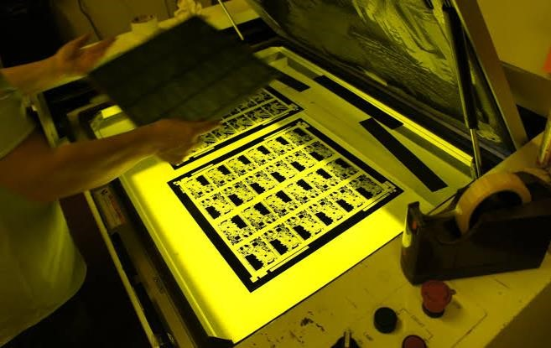

**ETCHING** : PCB etching is a process of removal of unwanted copper from the circuit board when I say unwanted it is nothing but the non circuit copper that is removed from the board as per the PCB design as a result, the desired circuit pattern is achieved in other word, etching is like chiseling the circuit board.

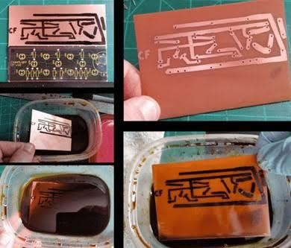

**DRILLING** : Drilling is a slow process as each hole must be drilled individually so depending on t drill size we drill stack of one to three PCB panels together we can drill holes down to 100 microns in diameter.

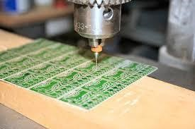

**MASKING**: Soldermask is a protective layer of liquid photo image lacquer applied on the top and bottom side of printed circuit board the function of the soldermask is protect the copper,apart from the solder pads from:oxidiation creating shorts during soldering.

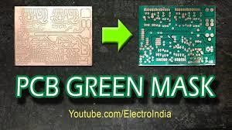

**SILKSCREEN**: It is a layer that uses ink traces to identify all the PCB board components test points, parts of the PCB, warning symbols, logos and marks etc.

**ROUTE :** In electronic design, wire routing, commonly called simply routing as asteps in the design pf printed circuits boards (PCBs)and integrated circuits (Ics)after placement, the routing steps add wires needed to proper connect the placed components while obeying all design rules.

**ELECTRICAL TEST :** Electrical test to check at the end of the PCB production process we use elect interconnectivity of the PCB is correct against the original board data.

**BREAD BOARD OUTPUTS:**

When the Intenstivity of the light is high the light does not glows.

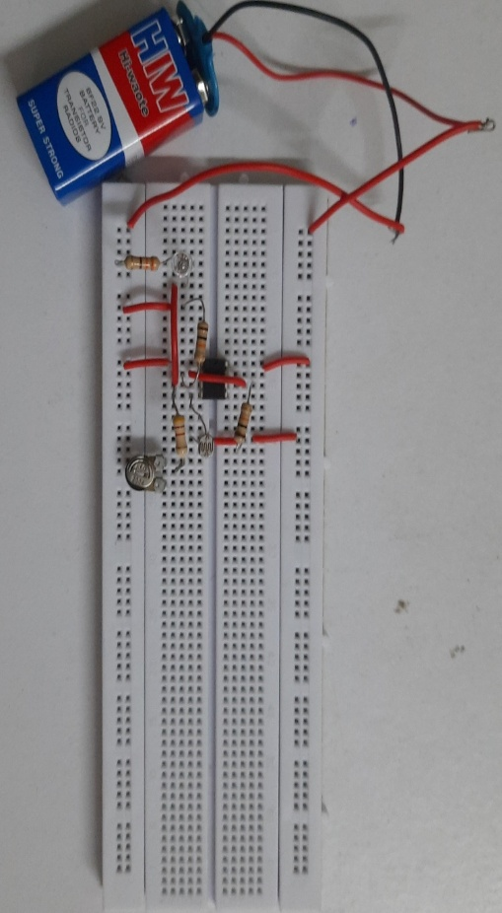

When the intenstivity of the light is low the light glows up.

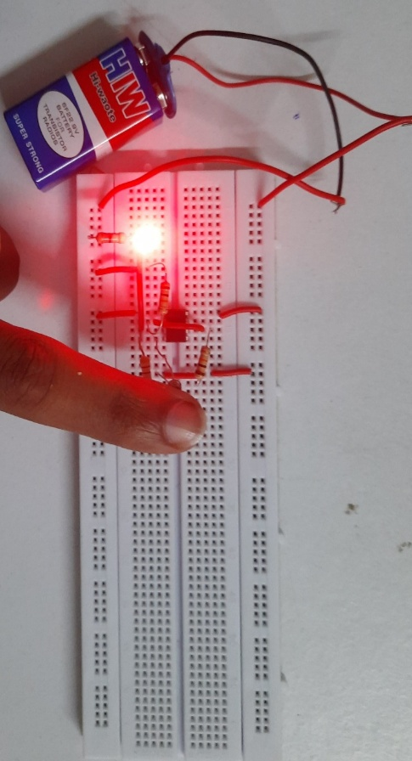

**CONCLUSION:** From this project, we have learned the operation of 555-timer. We know that the 555-timer IC gets activated when its reset pin (pin-4) receives a voltage greater than 0.8V. to keep the outputs turn ON. So the LDR is connected to the pin-4 to activate the IC, when the Itenstivity of the light is low and the Intenstivity of the light is more the power not flows through pin-4 so the IC is deactivated and the outputs are turned OFF.